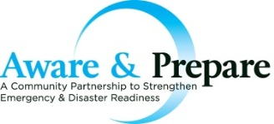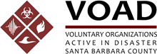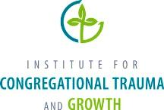

2014 Faith-Based and Community Partnerships Forum

Registration Form

Please include the following information for each Attendee in an email, letter, or fax to:

Tony Mitchell, Chair, Santa Barbara County VOAD
Email: amitchell@cacsb.com
Address: 5638 Hollister Ave Suite 230, Goleta, CA 93117
Telephone: (805) 964-8857 x 130
Fax: (805) 683-4276

Attendee Information: This free event will include continental breakfast, lunch, and on-site parking. Please submit this form as soon as possible as seating is limited.
Event Information: The event will be held on October 2, 2014 from 9:00 am to 3:30 pm.
Please be sure to arrive early to ensure prompt check-in!
Address:
First Presbyterian Church
21 East Constance Ave.
Santa Barbara, CA 93105

Name: _________________________ Title: ________________________________

Organization:____________________ Type of Organization: ____________________

Phone: _________________________ Email Address: _________________________

Organization Address: _________________________________
_________________________________

I will need this reasonable accommodation during the forum:
___________________________________________________________________

About The Sponsor Organizations
The Institute for Congregational Trauma & Growth (ICTG) is a national organization that promotes a faith-based healing response to tragedies by providing foremost research, education, and networking for congregations, their leaders, and their neighbors.
Santa Barbara County Volunteer Organizations Active in Disaster (SBC VOAD) is a convening and coordinating vehicle for organizations to build disaster resiliency and partner in disaster recovery with government agencies in Santa Barbara County.
Aware & Prepare is a public-private partnership to enhance the capabilities of non-profit organizations and government agencies to mitigate, prepare for, respond to, and recover from emergencies and disasters within Santa Barbara County.

